**Create and configure sensitivity labels**

1. In your labelling admin center, navigate to sensitivity labels:
   * Microsoft 365 compliance center:
     + **Solutions** > **Information protection**

If you don't immediately see this option, first select **Show all**.

* + Security & Compliance Center:
    - **Classification** > **Sensitivity labels**

1. On the **Labels** page, select **+ Create a label** to start the New sensitivity label wizard.

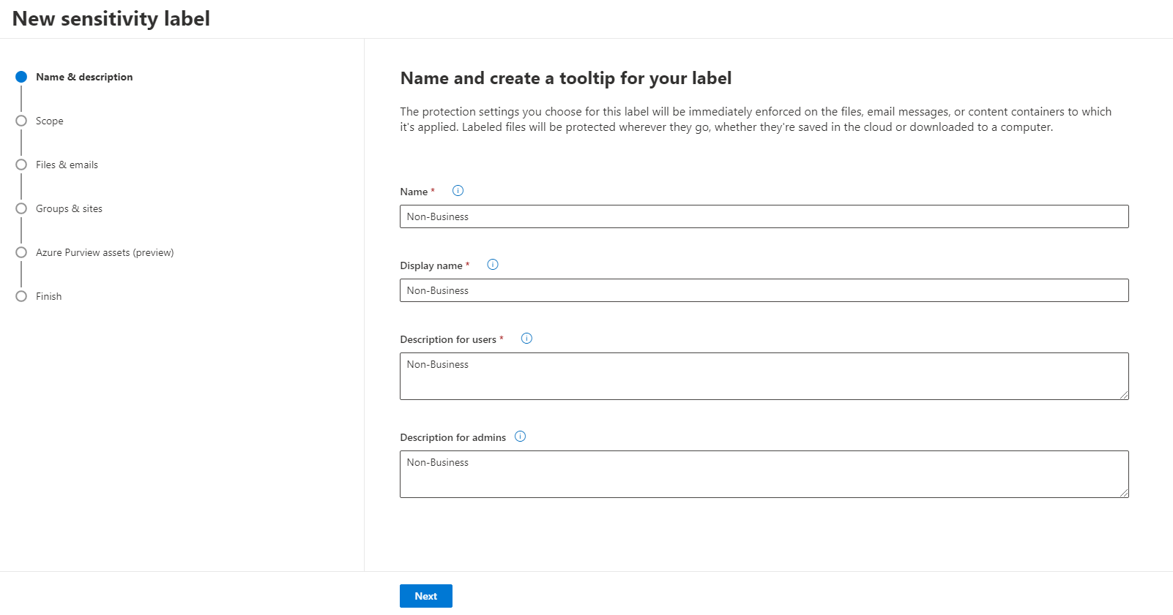

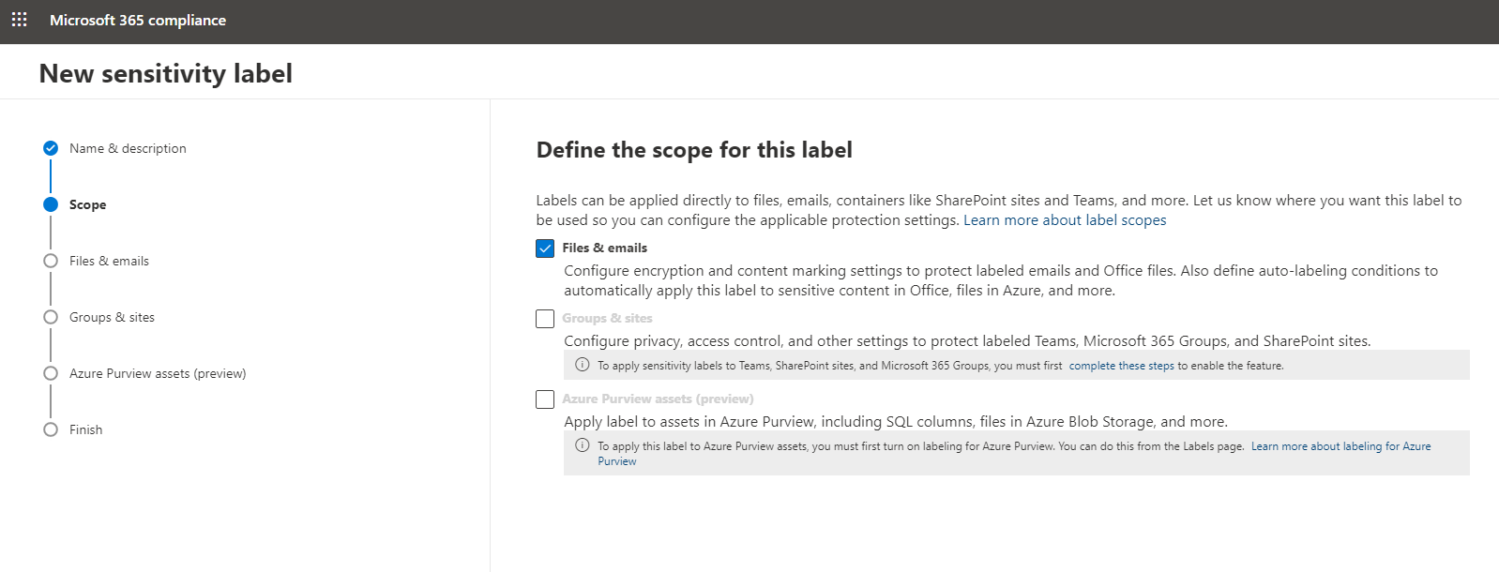

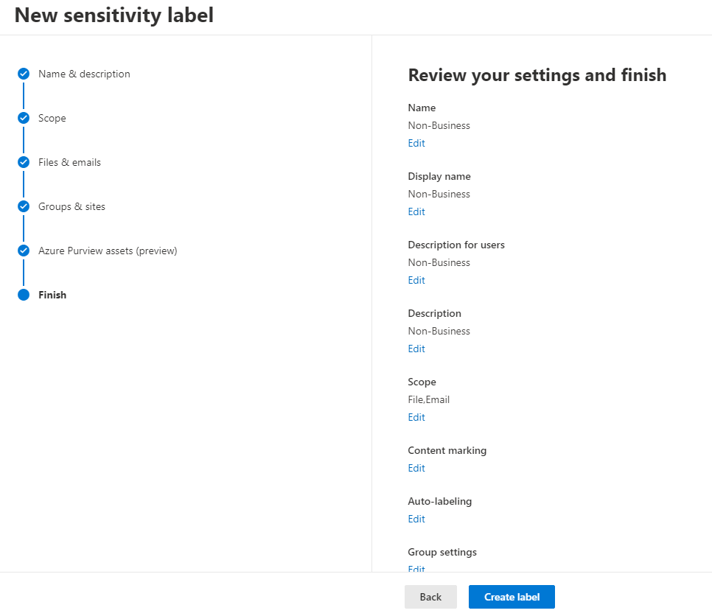

For Confidential

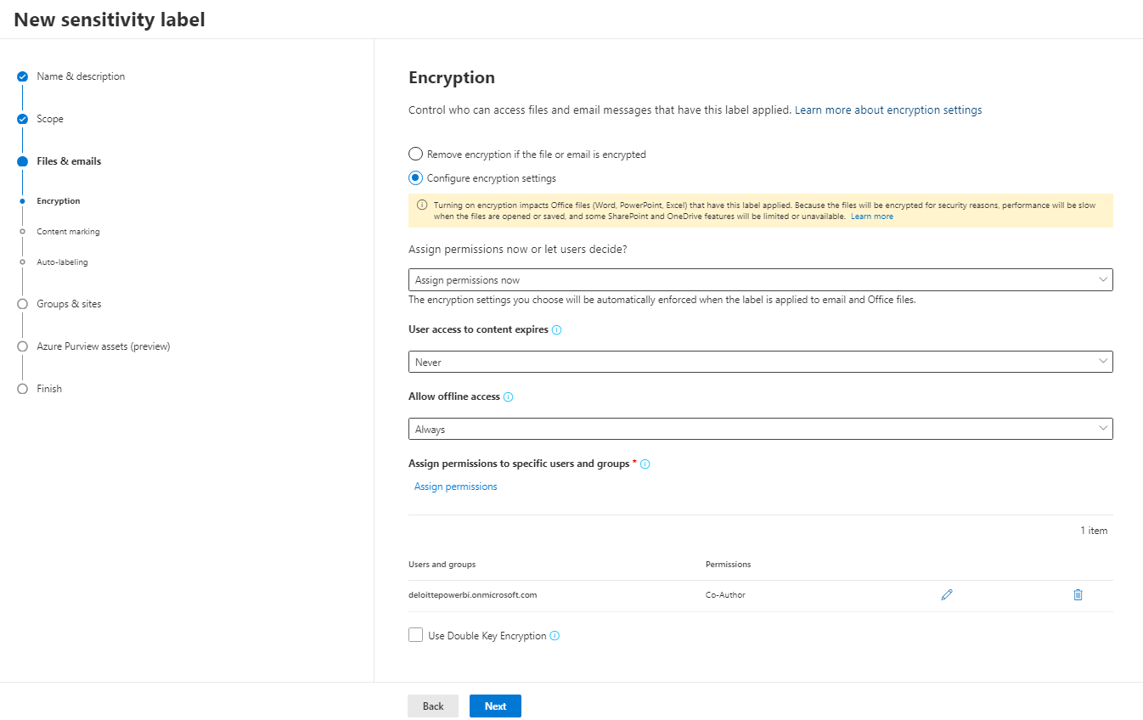

For example, from the Microsoft 365 compliance center:

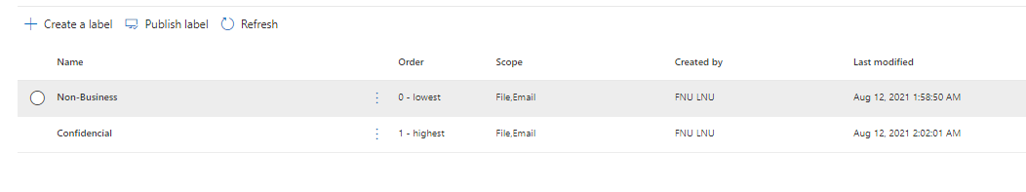

Then Publish the Label

Click Publish Label

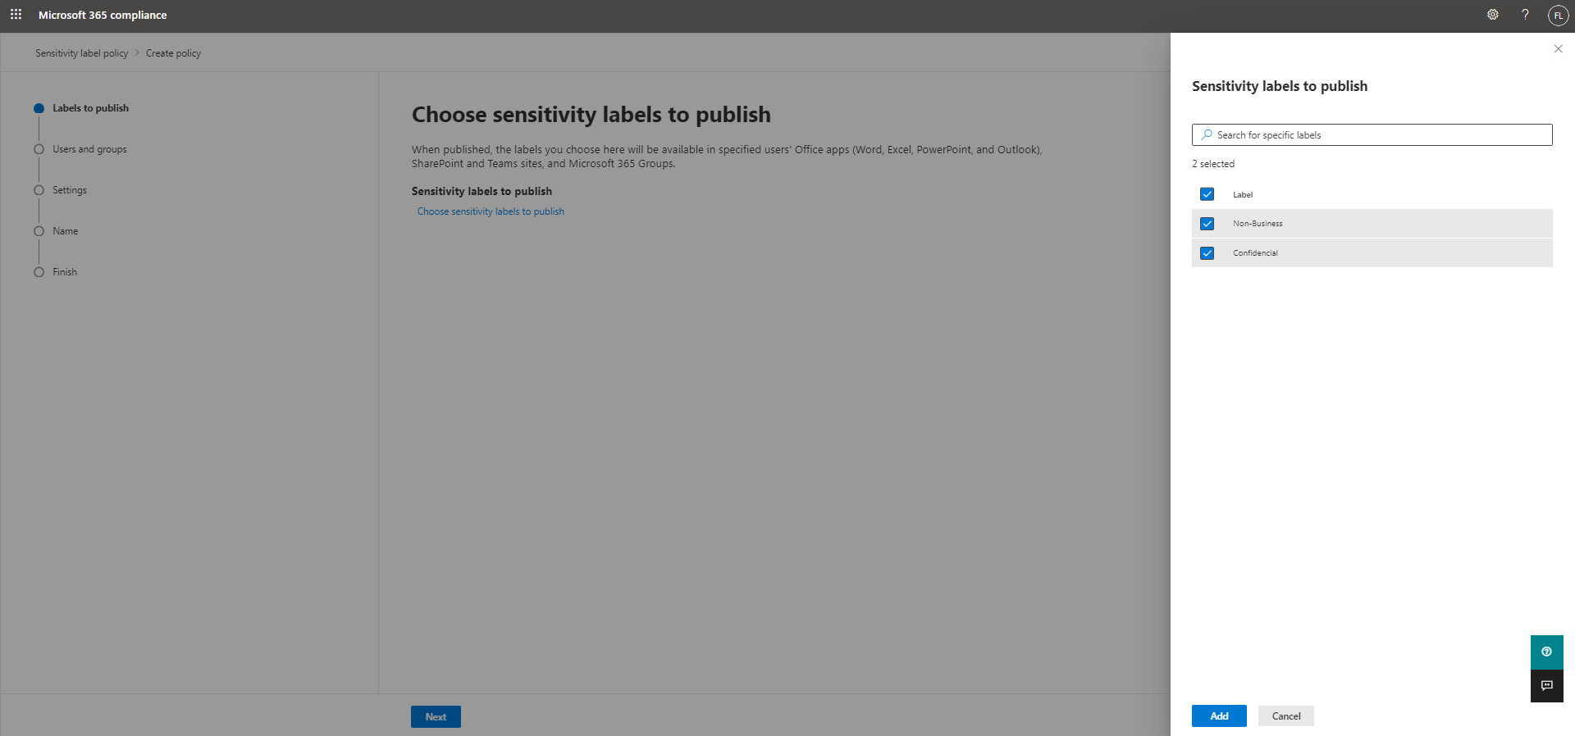

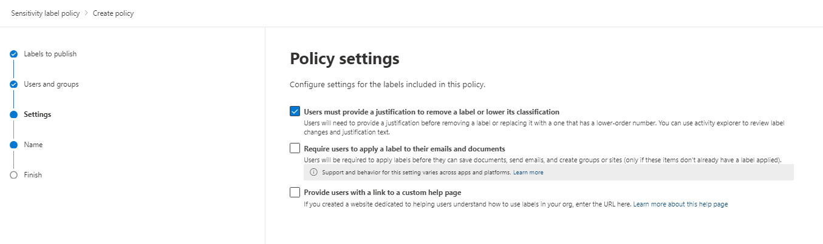

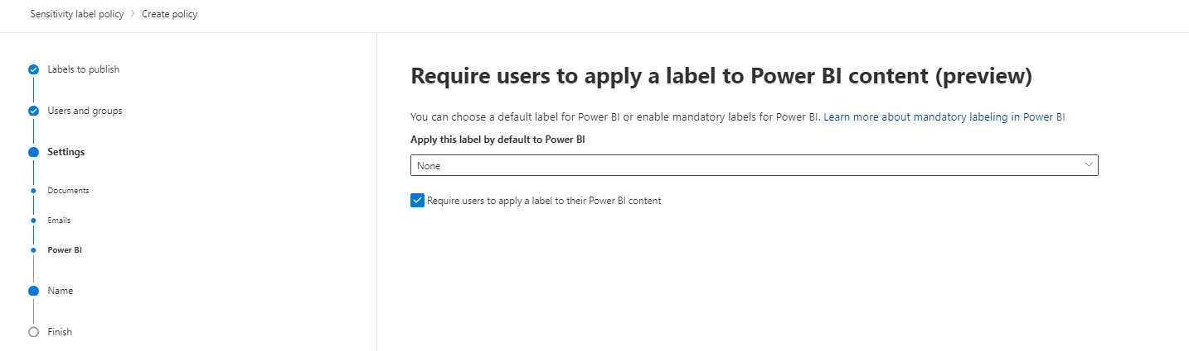

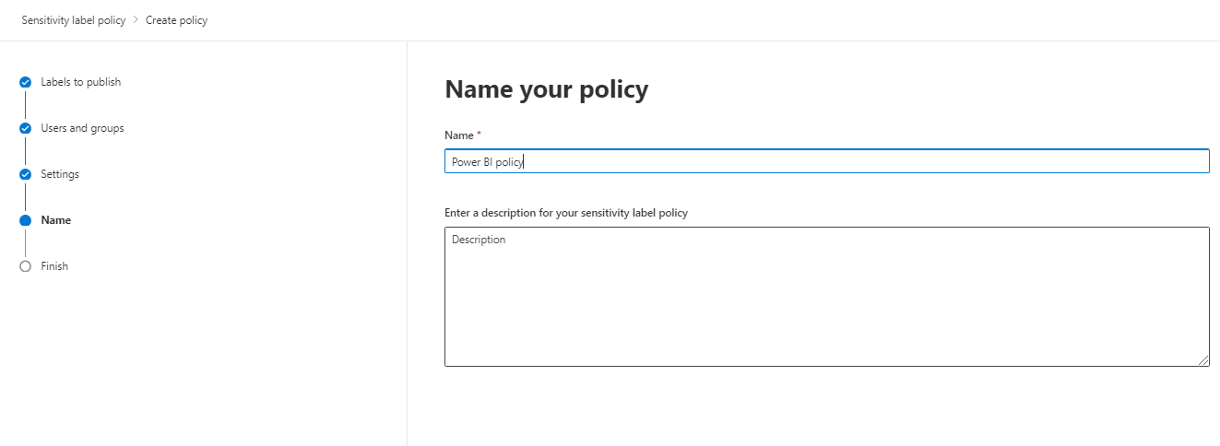

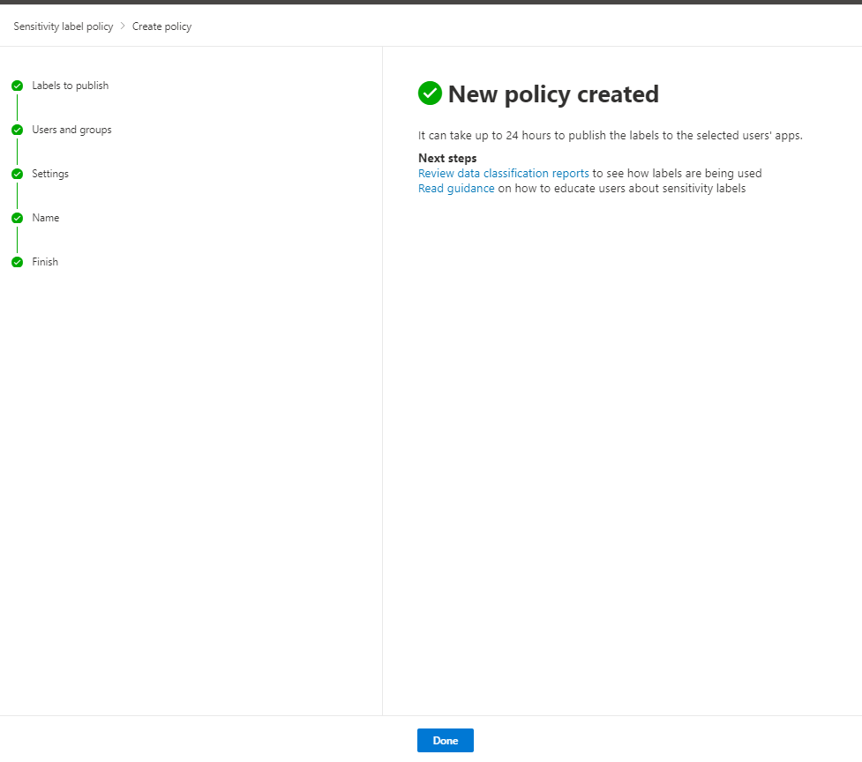

**Enable sensitivity labels**

Sensitivity labels must be enabled on the tenant before they can be used in both the service and in Desktop. This section describes how to enable them in the tenant settings.

To enable sensitivity labels on the tenant, go to the Power BI **Admin portal**, open the **Tenant settings** pane, and find the **Information protection** section.

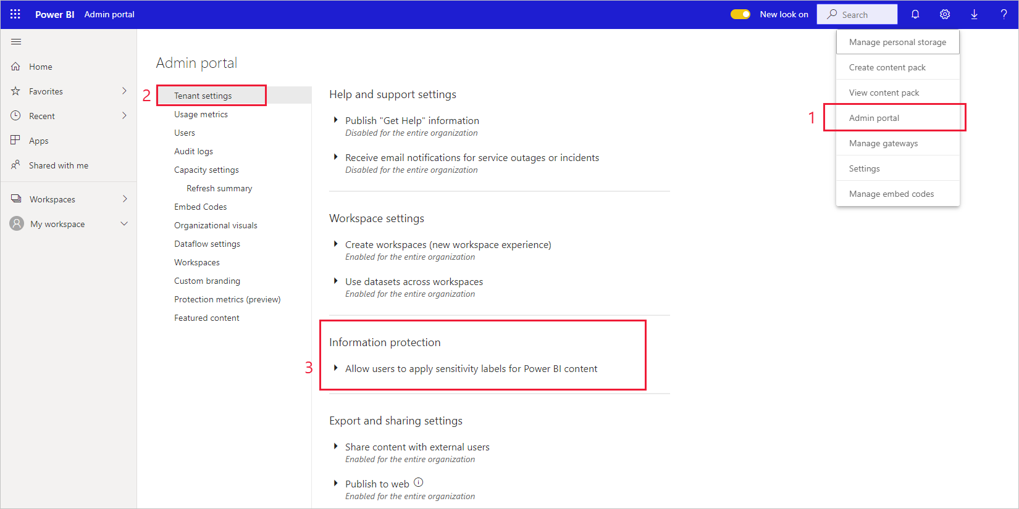

In the **Information Protection** section, perform the following steps:

1. Open **Allow users to apply sensitivity labels for Power BI content**.
2. Enable the toggle.
3. Define who can apply and change sensitivity labels in Power BI assets. By default, everyone in your organization will be able to apply sensitivity labels. However, you can choose to enable setting sensitivity labels only for specific users or security groups. With either the entire organization or specific security groups selected, you can exclude specific subsets of users or security groups.
   * When sensitivity labels are enabled for the entire organization, exceptions are typically security groups.
   * When sensitivity labels are enabled only for specific users or security groups, exceptions are typically specific users.  
     This approach makes it possible to prevent certain users from applying sensitivity labels in Power BI, even if they belong to a group that has permissions to do so.
4. Press **Apply**.

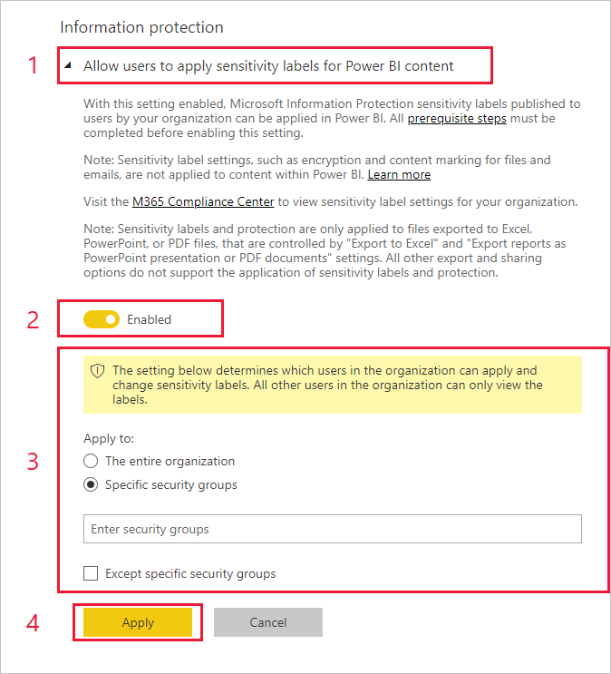

**Apply sensitivity labels in the Power BI service**

In the Power BI service, you can apply sensitivity labels to reports, dashboards, datasets, and dataflows.

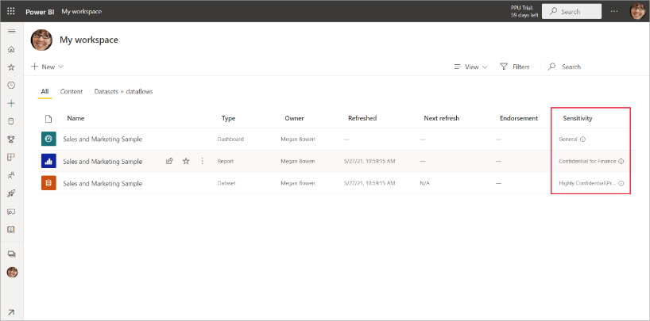

**To apply or change a sensitivity label on a report or dashboard**

1. Go to **Settings**.
2. In the settings side pane, go to the Sensitivity label section and choose the appropriate sensitivity label.
3. Save the settings.

The following image illustrates these steps on a report

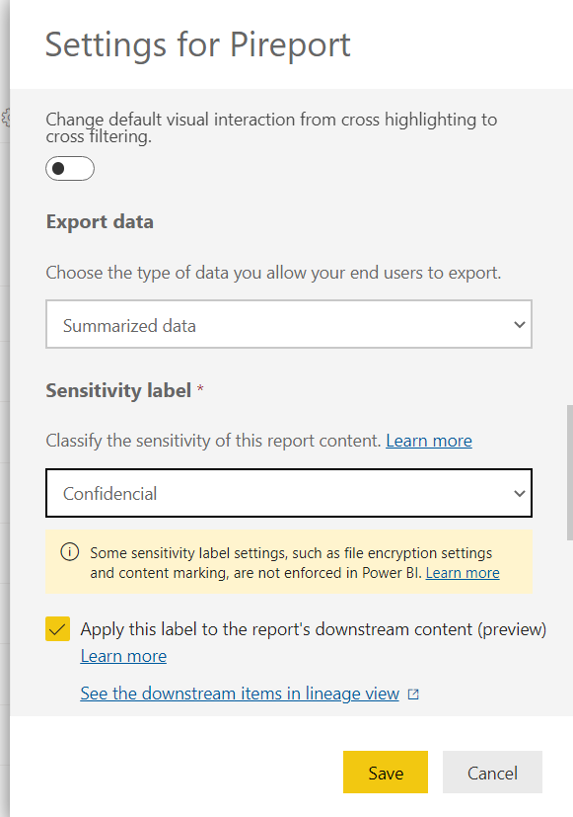

**To apply or change a sensitivity label on a dataset or dataflow**

1. Go to **Settings**.
2. Select the datasets or dataflows tab, whichever is relevant.
3. Expand the sensitivity labels section and choose the appropriate sensitivity label.
4. Apply the settings.

The following two images illustrate these steps on a dataset.

Choose **More options (...)** and then **Settings**.

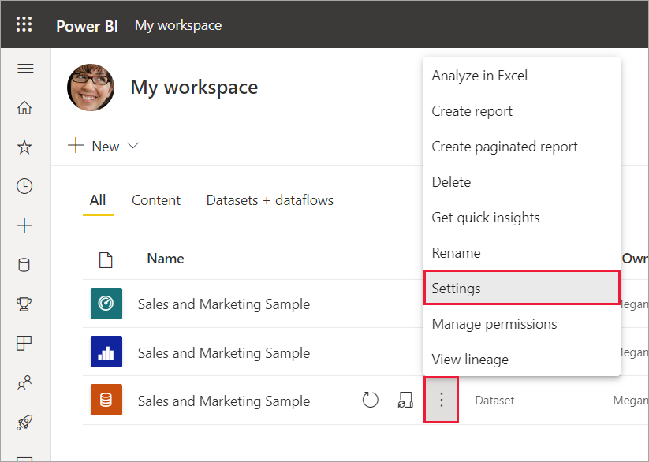

On the settings datasets tab, open the sensitivity label section, choose the desired sensitivity label, and click **Apply**.

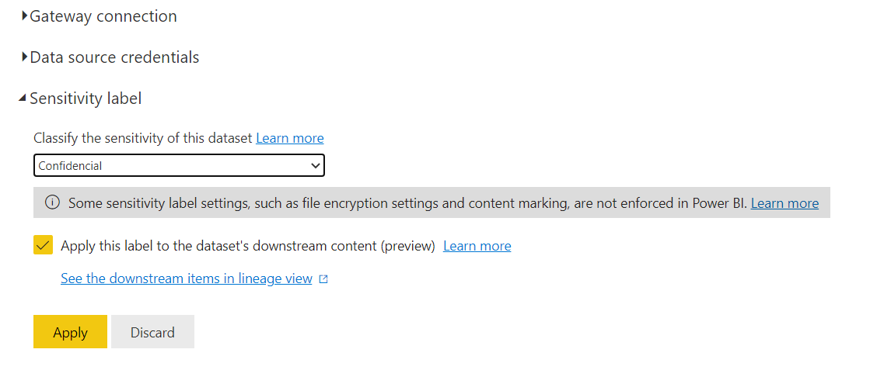

**Apply sensitivity labels in Power BI Desktop**

To apply a sensitivity label on the file you're working on, click the sensitivity button in the home tab and choose the desired label from the menu that appears.

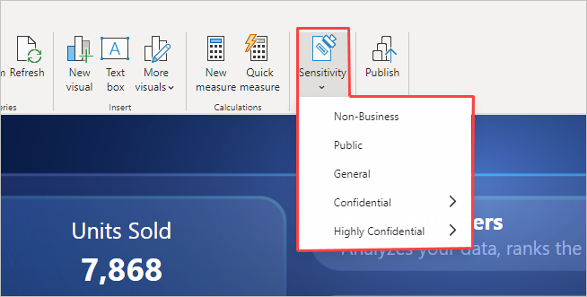

After you've applied the label, it will be visible in the status bar.

